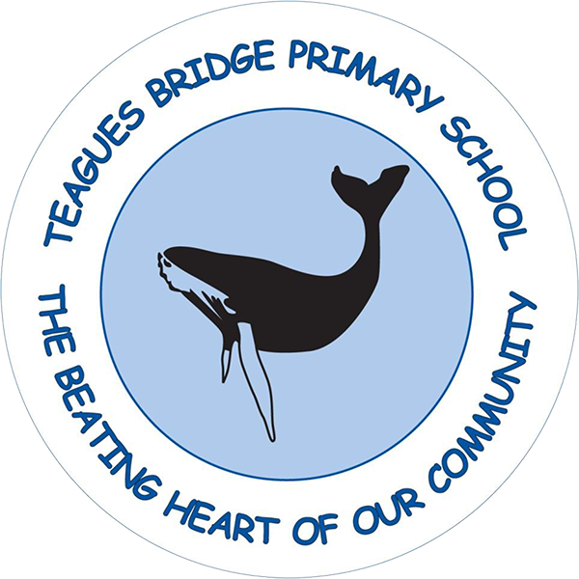


Year: ___

Name: _____________

Year 6
8. Read musical notes

9. Collaborate with another key stage
10. Learn a song in a different language

CONGRATULATIONS!
You’ve completed your 10 things to do before you’re 10!



Year 5

5. Attend a music workshop

6. See a live Orchestra

7. Perform to an audience

Year 3

- Learn to play an instrument

2. Compose a song

Year 4

3. Record your music

4. Create a Music Playlist

