Maths planning document
Teagues Bridge Primary school
2023 – Year 6
Written on: | 30th March 2020
Reviewed on: | March 2023
Next review: | March 2024
Staff Responsibility | Mr M Hale
Governor responsibility | Drew White

This document supported by the CLIC maths program providing teaching and consolidation of mental strategies for mathematics and the white rose small steps for teaching sequences. Weeks are a guideline and should be adapted for the needs of the children. Time for consolidation is designed for recapping of previous units to ensure learning in committed to the long-term memory. This can also be used to teach areas of misconceptions.

Mathematics Intent

At Teagues Bridge, our intention is ambitious. We aim to create strong mathematicians who have the necessary skills and understanding to tackle mathematical challenges in varying contexts, including the ability to reason and apply their knowledge to solving problems. This should mean that children are able to apply their knowledge to everyday life and can aspire to achieve anything that they want. We want our pupils to have strong mental manipulation and to use written strategies when appropriate.

Our philosophy for mathematics is replacing an idea that maths is lots of rules and numbers with a study of patterns and connected ideas. In early years they will build a foundation of number understanding and representation through mainly concrete and pictorial representations. The approach will be supported by in depth questioning, throughout the school to develop mastery.
Use of CPA is encouraged to ensure the curriculum is accessible for all children and that they all have the opportunity and are able to demonstrate their understanding in a variety of ways. This will enable them to have a good understanding of maths and not just the ability to follow a procedure. We want to empower them to want to ask questions and want to find the answers.

Aims: The national curriculum for mathematics aims to ensure that all pupils:
- become fluent in the fundamentals of mathematics, including through varied and frequent practice with increasingly complex problems over time, so that pupils develop conceptual understanding and the ability to recall and apply knowledge rapidly and accurately.
- reason mathematically by following a line of enquiry, conjecturing relationships and generalisations, and developing an argument, justification or proof using mathematical language
- can solve problems by applying their mathematics to a variety of routine and nonroutine problems with increasing sophistication, including breaking down problems into a series of simpler steps and persevering in seeking solutions.

Mathematics is an interconnected subject in which pupils need to be able to move fluently between representations of mathematical ideas. The programmes of study are, by necessity, organised into apparently distinct domains, but pupils should make rich connections across mathematical ideas to develop fluency, mathematical reasoning and competence in solving increasingly sophisticated problems. They should also apply their mathematical knowledge to science and other subjects.

The expectation is that the majority of pupils will move through the programmes of study at broadly the same pace. However, decisions about when to progress should always be based on the security of pupils’ understanding and their readiness to progress to the next stage. Pupils who grasp concepts rapidly should be challenged through being offered rich and sophisticated problems before any acceleration through new content. Those who are not sufficiently fluent with earlier material should consolidate their understanding, including through additional practice, before moving on.

Our lessons are structured to enable all children to achieve and have an opportunity to make progress with their learning. Each lesson begins with a CLIC maths activity, where they have chance to develop their mental strategies, secure number facts and number manipulation. They then develop their mathematical fluency with the teacher modelling and explaining before they have a go themselves. Children then have a reasoning/ problem solving activity which is a variation of the previous work to demonstrate they have mastered the objective. Children who are ready can then challenge themselves with a task that requires applying the learning to a greater depth. We have our own programme of study which is supported with schemes like White Rose to support.

Year 6 – Yearly Overview

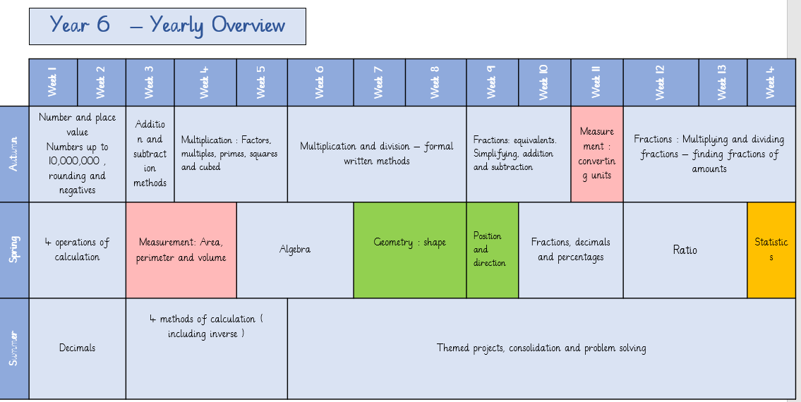

Year 6: Autumn term
National curriculum objectives | Prior knowledge from year 6 | Learning outcomes (including WR steps) | Mathematical aspect | Vocabulary | Manipulatives | Problem solving resources
Read, write, order and compare numbers up to 10,000,000 and determine the value of each digit  Solve number and practical problems that involve the above (runs through the place value unit) | Knows how to read and write numbers with up to 8 digits using the comma separator. | Maths resources for teachers | White Rose Maths  Steps 1 to 5  LO I know numbers to 1,000,000  LO I know numbers to 10,000,000  LO I know how to read and write numbers to 10,000,000  LO I know how to use powers of 10  LO I know calculating on a number line to 10,000,000  LO I know comparing numbers to 10,000,000  LO I know ordering numbers to 10,000,000 | Number and place value – including negative numbers | ten thousands  (10,000s)  hundred thousands (100,000s)  millions (1,000,000s) ten million (10,000,000)  place value  partition  interval  estimate | Place value charts  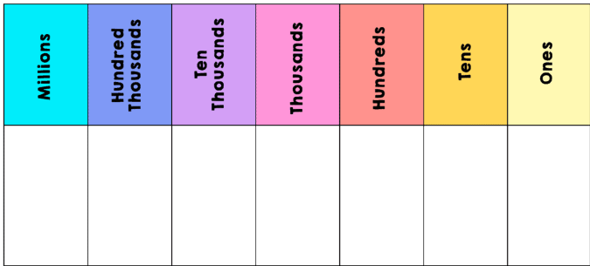  Place value counters  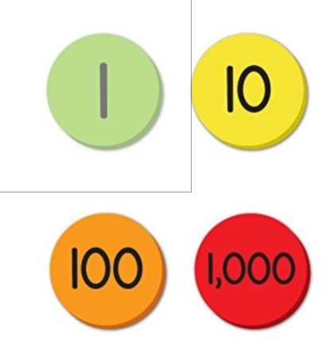  Base ten equipment  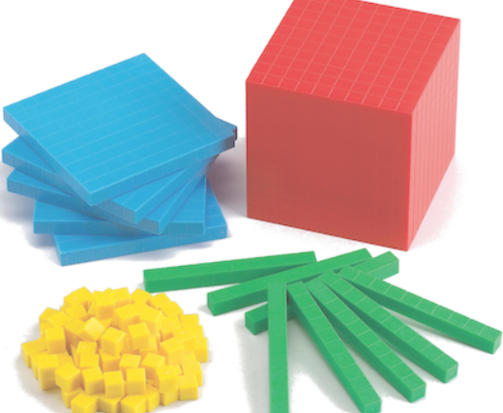 | Counting forwards and backwards  Space Distances *  Solve number and practical problems that involve all of the above  Round the Four Dice * I  Number Lines in Disguise **
Round any whole number to a required degree of accuracy | Knows rounding numbers to 1,000,000 | Step 7  LO I know rounding numbers to 10,000,000 | Number and place value : rounding | ten thousands  (10,000s)  hundred thousands (100,000s)  millions (1,000,000s) ten million (10,000,000)  rounding | Place value charts  Place value counters  Base ten equipment | Round the Four Dice * I
Use negative numbers in context, and calculate intervals across zero | Knows how to calculate with negative and positive numbers. | Step 8  LO I know negative numbers | Number and place value – including negative numbers | negative  positive | negative number line | Use negative numbers in context, and calculate intervals across zero  First Connect Three * G
Solve addition and subtraction multi-step problems in contexts, deciding which operations and methods to use and why | Knows efficient mental methods for addition and subtraction.  Knows the formal written methods of columnar addition and subtraction with increasingly large numbers and decimals. | Maths resources for teachers | White Rose Maths  Step 1  LO I know how to add numbers to 10,000,000  LO I know how to subtract numbers to 10,000,000 | Number: addition, subtraction, multiplication and division | add, addition, more, plus, increase sum, total, altogether score add, subtract | Place value charts  Place value counters  Base ten equipment  Numicon  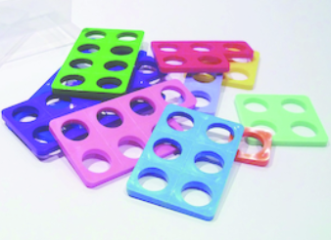
Identify common factors, common multiples and prime numbers |  | Maths resources for teachers | White Rose Maths  Steps 2 -5  LO I know common factors  LO I know common multiples  LO I know the riles of divisibility  LO I know prime numbers to 100. | Number: common factors and multiples | multiply  divide  Factor  common  factor  common multiple prime  composite | Place value charts  Multiplication grids | Solve problems involving addition, subtraction, multiplication and division  Always, Sometimes or Never? Number  Abundant Numbers * I  Three Dice *  Factor Track ** G
Solve problems involving addition, subtraction, multiplication and division | Knows the definition of square and cube numbers and the correct notation. | Step 6  LO I know squared numbers  Lo I know cubed numbers | Number: squared and cubed numbers | Squared, cubed, multiply, multiplication facts, | Multiplication grids | Two Primes Make One Square ** I
Multiply multi-digit numbers up to four digits by a 2-digit whole number using the formal written method of long multiplication | Knows the efficient written algorithms for long multiplication and short division. | Step 7  Lo I know how to multiply 4 x 2 digit numbers | Number : multiplication | lots of, groups of times, multiply, multiplication, multiplied by multiple of, product once, twice, three times… ten times… times as (big, long, wide… and so on) repeated addition array row, column double, halve share, share equally  factor, multiple, prime, composite | Place value charts  Multiplication grids  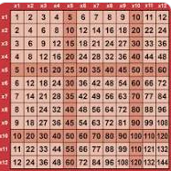 | Always, Sometimes or Never? Number
Perform mental calculations, including with mixed operations and large numbers | Knows efficient mental methods for multiplication and division. | Step 8  LO I know how to solve problems using multiplication methods | Number: Multiplication | lots of, groups of times, multiply, multiplication, |  | Become Maths Detectives * I  Exploring Number Patterns You Make ** I
Divide numbers up to four digits by a 2-digit number using the formal written method of short division where appropriate, interpreting remainders according to the context | Knows the compact algorithm for short division including remainders. | Step 9 -13  LO I know to divide 4 by 1 digit numbers  LO I know to divide using factors  LO I know to divide 4 by 2 digit numbers  LO I know to divide 4 by 2 digit numbers including remainders. | Number: division
Solve problems involving addition, subtraction, multiplication and division | Knows efficient mental methods for multiplication and division. | Steps 13 and 14  LO I know to solve problems with division  LO I know to solve multi-step problems | Number : problem solving | halve share, share equally | Place value charts  Multiplication grids | Division Rules * I  Odd Squares *  Cubes Within Cubes ***  Curious Number *** I
Use their knowledge of the order of operations to carry out calculations involving the four operations |  | Steps 15  LO I know how to calculate using the order of operations | Number : order of operations | BIDMAS
Use estimation to check answers to calculations and determine, in the context of a problem, an appropriate degree of accuracy | Know the test of divisibility for 2, 5 and 10.  3- digit sum of 3, 6 or 9.  4 multiple of 4 in tens and ones.  6 – even and digit sum of 3,6 or 9. | Step 16  Lo I know to use mental calculations and estimation  Step 17  Lo I know to find facts from known facts | Number : estimations |  |  | Four Go * G
Use common factors to simplify fractions; use common multiples to express fractions in the same denomination | Knows how to convert fractions to a common denominator for addition and subtraction | Maths resources for teachers | White Rose Maths  Step 1 - 2  Lo I know to find equivalent factions  LO I know to simplify fractions | Fractions: equivalents , addition and subtraction
Compare and order fractions, including fractions > 1 | Knows how to multiply proper fractions and mixed numbers using the rule of dividing by 1 to represent the whole number as a fraction. | Steps 3 and 4  LO I know to compare and order using the denominator  Lo I know to compare and order using the numerator | Fractions: comparing and ordering | numerator denominator common denominator common factor equivalent simplify simplest form factor highest common factor lowest common multiple (LCM) compare order ascending descending proper fraction improper fraction mixed number convert lowest common denominator | Fraction tiles  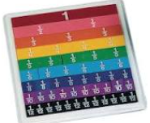  Cuisenaire rods  Fractions circles  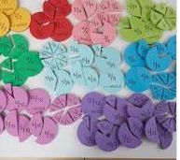  Numicon | Compare and order fractions, including fractions >1  More Fraction Bars **  Extending Fraction Bars **  Fraction Lengths **
Add and subtract fractions with different denominators and mixed numbers, using the concept of equivalent fractions | Knows how to calculate with fractions. | Steps 5 to 9  Lo I know adding two fractions with different denominators  Lo I know subtracting two fractions with different denominators  Lo I know adding mixed numbers  Lo I know subtracting mixed numbers  LO I know solving multi-step problems | Fractions : adding and subtracting | numerator denominator common denominator common factor equivalent simplify simplest form factor highest common factor lowest common multiple (LCM) compare order ascending descending proper fraction improper fraction mixed number convert lowest common denominator | Fraction tiles  Cuisenaire rods  Fractions circles  Numicon | Fraction Lengths **
Use, read, write and convert between standard units, converting measurements of length, mass, volume and time from a smaller unit of measure to a larger unit, and vice versa, using decimal notation to up to 3 decimal places  Solve problems involving the calculation and conversion of units of measure, using decimal notation up to 3 decimal places where appropriate ( running through the unit in problem solving ) | Knows how to use place value, multiplication, and division to convert between standard units. | Maths resources for teachers | White Rose Maths  Steps 1- 5  Lo I know metric measurements  Lo I know how to convert metric measurements  LO I know how to calculate with metric measurements  LO I know to convert between miles and kilometres  LO I know imperial measurements | Measurement: converting units | metric  imperial unit of measurement (or measure)  gram (g)  kilogram (kg)  pound (lbs)  ounce (oz)  mass  millilitre (ml)  litre (l)  pint  capacity  millimetre (mm)  centimetre (cm)  metre (m)  kilometre (km)  inch (in) foot (ft) yard (yd) mile length convert conversion table conversion graph | Converting formula for measurements  Place value charts  Place value counters  Conversions between metric and imperial measures | Next Size Up **
Multiply simple pairs of proper fractions, writing the answer in its simplest form | Knows how to multiply proper fractions and mixed numbers using the rule of dividing by 1 to represent the whole number as a fraction. | Maths resources for teachers | White Rose Maths  Steps 1 to 2  LO I know to multiply fractions by whole numbers  Lo I know to multiply fractions by fractions | Fractions : multiplying , dividing and fractions of amounts
Divide proper fractions by whole numbers | Knows how to multiply proper fractions and mixed numbers using the rule of dividing by 1 to represent the whole number as a fraction. | Step 3 and 4  LO I know to divide any fraction by a whole number  Lo I know to calculate with different fractions. | Fractions: dividing fractions by whole numbers | numerator denominator common denominator common factor equivalent simplify simplest form factor highest common factor lowest common multiple (LCM) compare order ascending descending proper fraction improper fraction mixed number convert lowest common denominator
Associate a fraction with division and calculate decimal fraction equivalents | Knows how to calculate with fractions. | Step 6 to 7  Lo To find fractions of amounts  Lo To find fractions of a whole | Fractions : finding fractions of amounts | numerator, denominator, |  | Fraction Lengths **

Year 6 Spring term
National curriculum objectives | Prior knowledge from year 5 | Learning outcomes (including WR steps) | Mathematical aspect | Vocabulary | Manipulatives | Problem solving resources
• Solve addition and subtraction multi-step problems in contexts, deciding which operations and methods to use and why  • Solve problems involving addition, subtraction, multiplication and division  Perform mental calculations, including with mixed operations and large numbers | -formal written method for addition and subtraction  - formal written method for long and short multiplication and short division | Step 1 : addition and subtraction of integers  Steps 7 – 14  4 operations of calculations.  Step 7 : Mutlipying 4 by 2 digit number  Step 8 : Solve problems with multiplication  Step 9 Short division  Step 11 – Long division  Step 12 – Long division with remainders | Calculation 4 operations of calculation | add, addition, more, plus, increase sum, total, altogether score add, subtract  lots of, groups of times, multiply, multiplication, multiplied by multiple of, product once, twice, three times… ten times… times as (big, long, wide… and so on) repeated addition array row, column double, halve share, share equally  factor, multiple, prime, composite | Place value charts  Place value counters  Base ten equipment  Numicon | Become Maths Detectives * I  Exploring Number Patterns You Make ** I
- Recognise that shapes with the same areas can have different perimeters and vice versa  - Recognise when it is possible to use formulae for area and volume of shapes |  | Steps 1 – 2  Step one: To find areas of shapes  Step two: To find area and perimeter | Area, perimeter and volume | Area, perimeter, length, width, volume, |  | Area and Perimeter * I  Through the Window * I  Dicey Perimeter, Dicey Area * G
- Calculate the area of parallelograms and triangles | Finding areas of rectangles  Finding the perimeter of rectangles | Steps 3 – 8  Step three- To find areas of triangles – counting squares  Step four – To find the area of right angled triangles  Step five – To find the area of any triangle  Step six – To find the area of parallelograms  Step seven – To find Volume by counting squares  Step eight – To find the area of cuboids. | Area, perimeter and volume | Triangle, angle, equilateral, isosceles, scalene, |  | Shaping It * I  Brush Loads * I  Cubes * I  Numerically Equal **  Making Boxes ** I  Ribbon Squares ***  Fitted ***  Next Size Up **
• Use simple formulae  • Generate and describe linear number sequences |  | Maths resources for teachers | White Rose Maths (whiteroseeducation.com)  Steps 1 - 10  Step one – LO I know how to use 1 step function machines  Step two – LO I know how to use 2 step function machines  Step three – LO I know how to form expressions  Step four – I know how to substitute in equation  Step five – I know how to express formulae  Step six – I know different forms of equations  Step seven – I know how to solve 2 step equations  Step eight – I know how to solve 2 step equations  Step nine – I can find pairs of values  Step ten – I can solve problems with two unknowns | Algebra | sequence rule term algebra expression calculation formula substitute generalise operation calculate equation inverse solution |  | Use simple formulae  Finding 3D Stacks ***  Doplication *  Diagonal Sums **  Generate and describe linear number sequences  Domino Sets * I  Break it Up! * I  Holes * I  Button-up Some More ** I  Find pairs of numbers that satisfy an equation with two unknowns  Price Match **  Express missing number problems algebraically  Plenty of Pens *  Two and Two *** I
- Recognise angles where they meet at a point, are on a straight line, or are vertically opposite, and find missing angles |  |  | Geometry – shape
- Compare and classify geometric shapes based on their properties and sizes and find unknown angles in any triangles, quadrilaterals, and regular polygons
- Illustrate and name parts of circles, including radius, diameter and circumference and know that the diameter is twice the radius
- Recognise, describe and build simple 3-D shapes, including making nets

Year 6 Summer term

National curriculum objectives | Prior knowledge from year 1 | Learning outcomes (including WR steps) | Mathematical aspect | Vocabulary | Manipulatives | Problem solving resources

